**Hackathon Instruction Document**

**#innominions**

**Follow us on Linkedin for more opportunities**

[**https://www.linkedin.com/company/innomaticshyd/**](https://www.linkedin.com/company/innomaticshyd/)

**Kindly read this document carefully**



**Challenge starts** at 1:00 PM, 22nd October, 2022 🕐

**Challenge ends** at 1:00 PM, 23rd October, 2022 🕐

**👉 Hackathon Task Link -** [**CLICK HERE**](https://docs.google.com/document/d/1BLB96D1tzylwvhZ3xmXtCGKNCIuAyBSF/edit?usp=sharing&ouid=101183190533718048323&rtpof=true&sd=true)

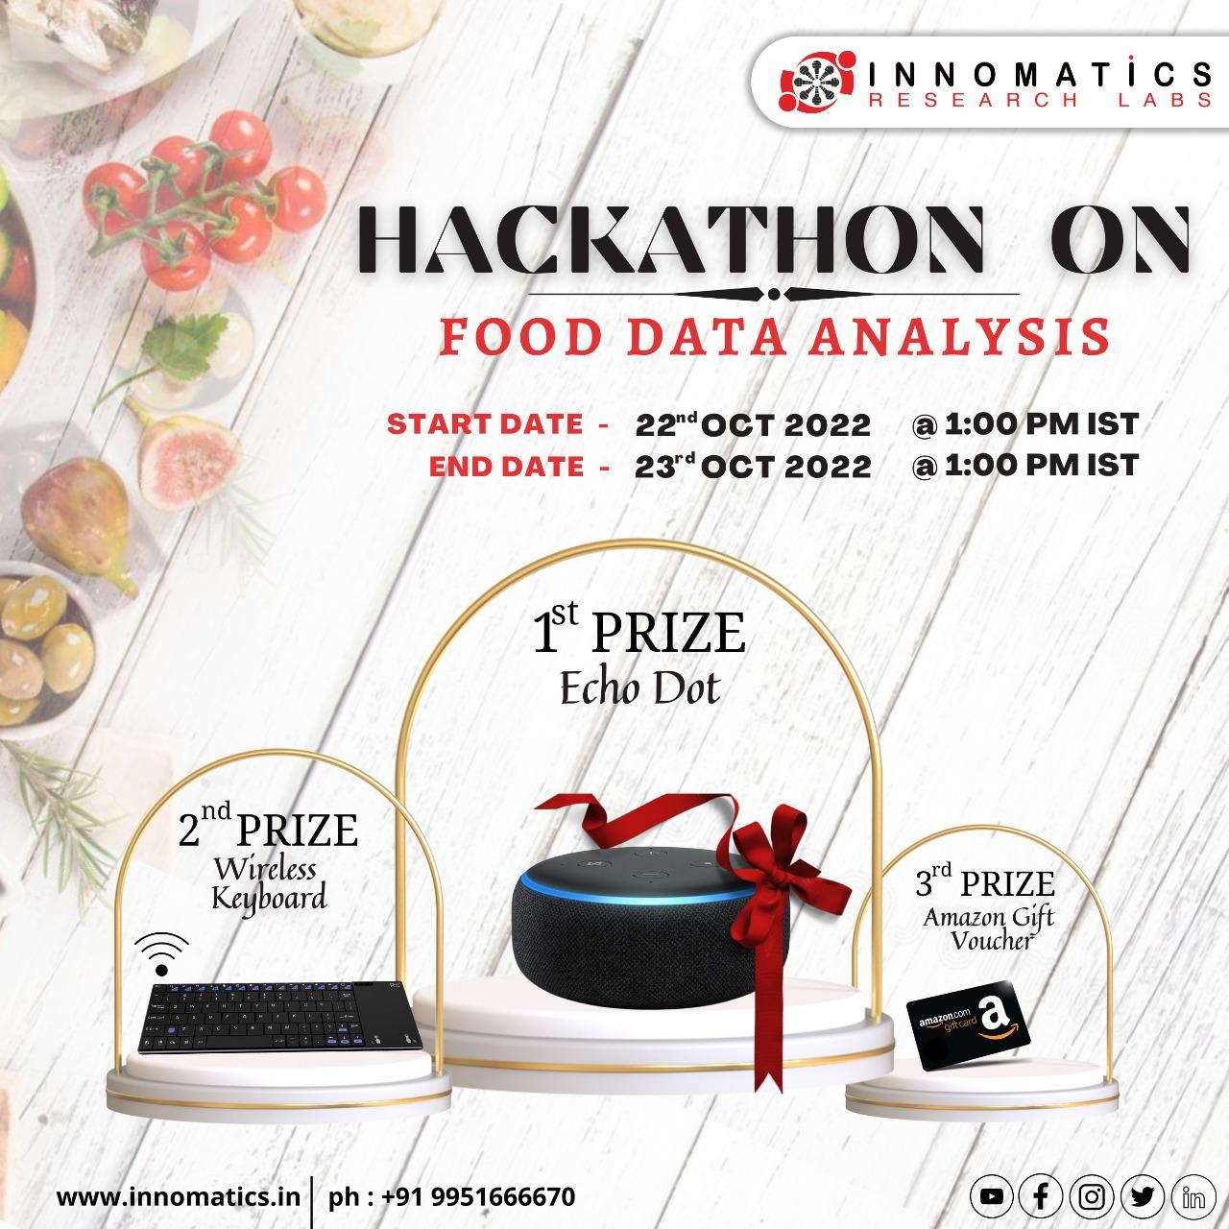

**👉 Hackathon Task Link -** [**CLICK HERE**](https://docs.google.com/document/d/1BLB96D1tzylwvhZ3xmXtCGKNCIuAyBSF/edit?usp=sharing&ouid=101183190533718048323&rtpof=true&sd=true)

**What's in it for you?**

1. Explore, Compete and Learn 🤣
2. Win exciting prizes like **Echo Dot, Wireless Keyboard, Amazon Gift Vouchers, Pizza Parties and more** 🎁
3. Best submissions will be invited for full time opportunities from our Hyderabad office
4. Get a chance to get the internship opportunity with **Innomatics Research Labs**
5. Pizza party 🍕 for lucky participants **(Comment with an emoji on our Linkedin post to enter the lucky draw)**

**How to Participate?**

1. Go to the [**Hackathon Task file**](https://docs.google.com/document/d/1BLB96D1tzylwvhZ3xmXtCGKNCIuAyBSF/edit?usp=sharing&ouid=101183190533718048323&rtpof=true&sd=true) in order to download the dataset and to read about the problem statement and hackathon task.
2. Start solving the problem by using your data analysis skills.
3. Submit your solution **before 23rd Oct, 2022 @ 1:00 PM** on [**this link**](https://forms.gle/TtgYRoBFXJzntrUS7).

**How to Win the Pizza Party and other gifts?**

**👉 Linkedin Post Link -** [**CLICK HERE**](https://www.linkedin.com/feed/update/urn:li:activity:6989483088443498496) **😋**

**Rewards -** Multiple participants will receive a pizza party/cash prizes during the hackathon event on both days. 🍕

**How to win?** - Selection of Pizza Party/cash prize winners will be purely random. Only the people who have **liked and commented** on **Linkedin Post** will be eligible for Pizza. 🤭

**👉 Linkedin Post Link -** [**CLICK HERE**](https://www.linkedin.com/feed/update/urn:li:activity:6989483088443498496) **😋**

**(Optional)** Win assured gifts by writing a post on Linkedin about the experience. Don’t forget to tag **Innomatics Research Labs** and use the hashtag mentioned below: **#Innominion #Innomatics**

**👉 Hackathon Task Link -** [**CLICK HERE**](https://docs.google.com/document/d/1BLB96D1tzylwvhZ3xmXtCGKNCIuAyBSF/edit?usp=sharing&ouid=101183190533718048323&rtpof=true&sd=true)

**How to submit?**

In order to submit your notebook/dashboard/work, fill this form after completing the Hackathon Task:

* 1. Click here to fill the form - [**Submission Form**](https://forms.gle/TtgYRoBFXJzntrUS7)
  2. Upload your solutions in the submission form.
  3. Only one submission per user is allowed.
  4. Deadline to submit is **23rd October, 2022 @ 1:00 PM**.
  5. Plagiarism will result in disqualification from this challenge and any future open challenge and internship opportunities.